PRACTICAL WEEK-9
Task-1: Implement a file copy utility using low-level Linux file 1/0 system calls (open, read, write, Iseek, close). Compare its performance with standard library functions (fopen, fread, fwrite).
Source code:
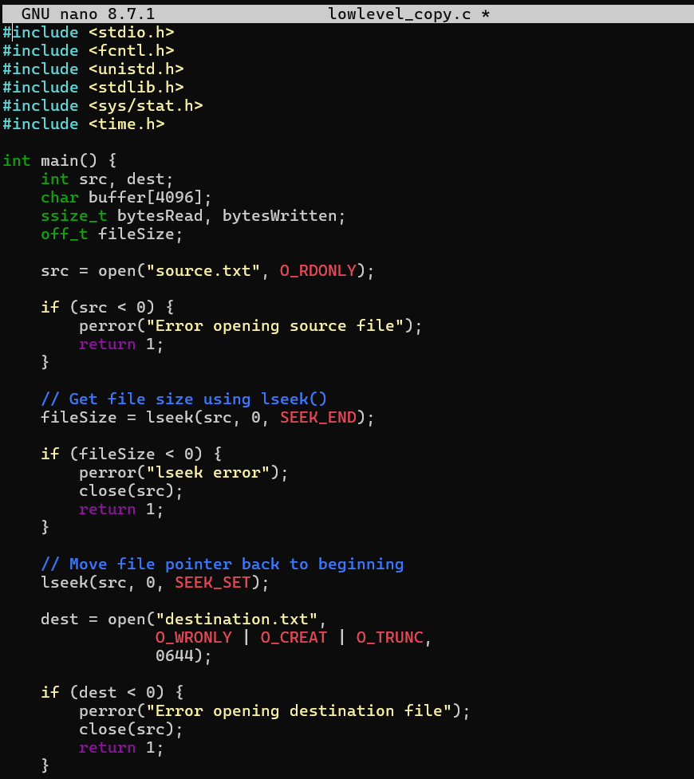
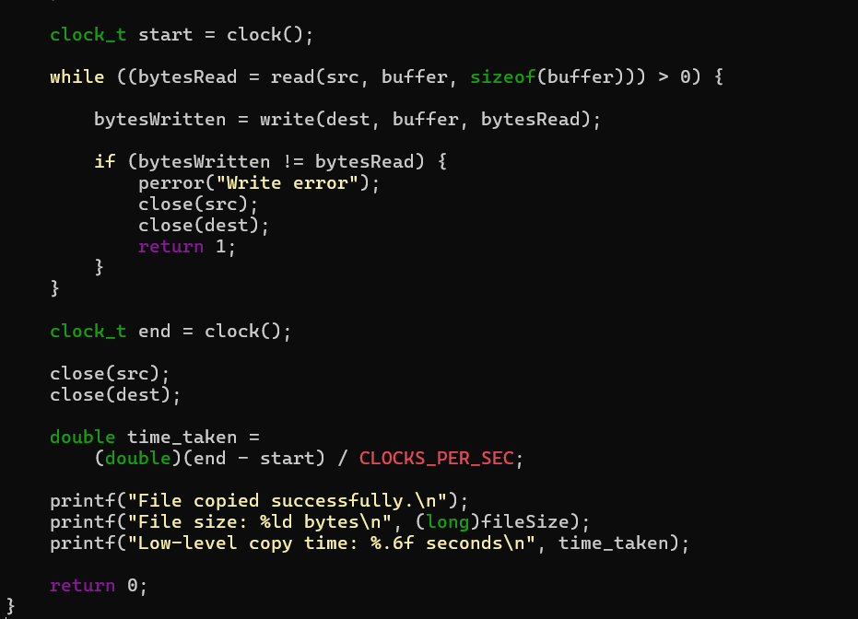

Output:
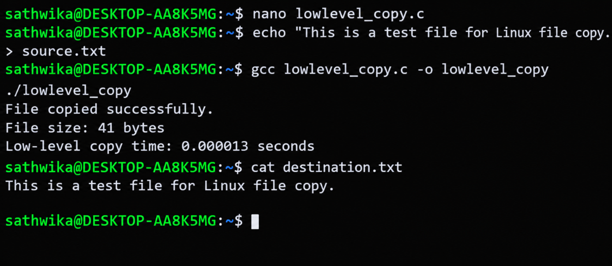
Observation:
The file was successfully copied using low-level Linux I/O system calls and standard C library functions. Their execution times were measured and compared.
Task-2: Develop a program that redirects standard input and Output using file descriptors and dup2(). Demonstrate how shells implement 1/0 redirection.
Source code:
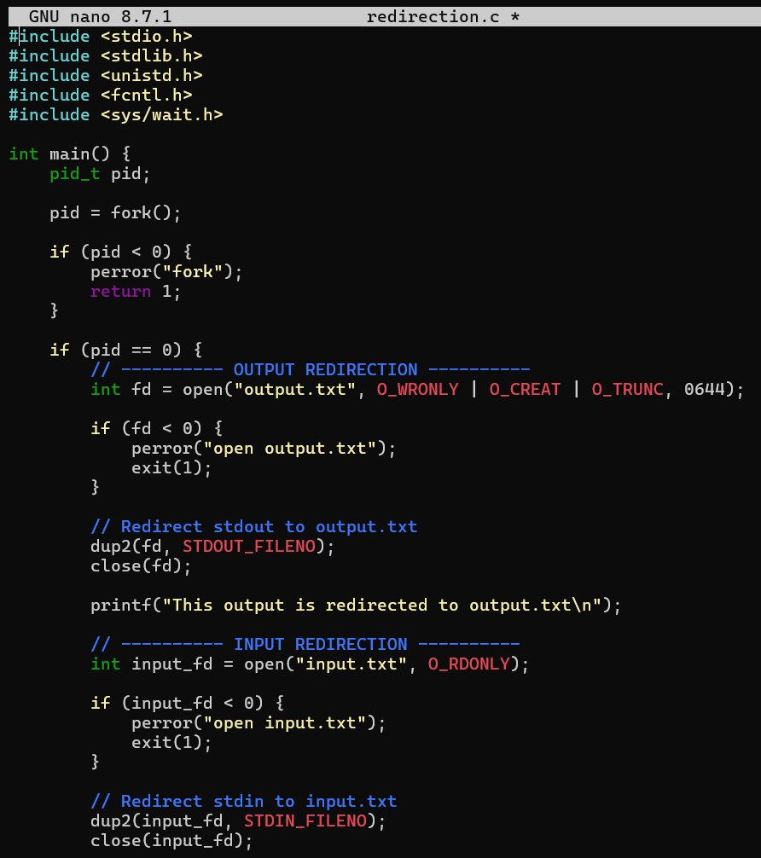

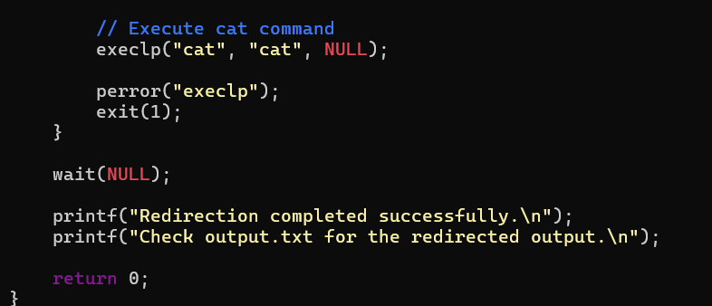

Output:
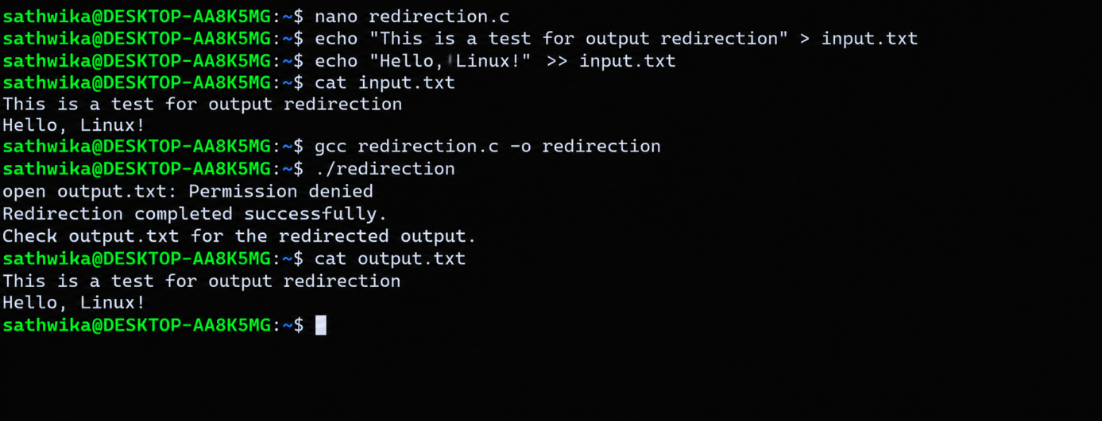
Observation:
The program successfully demonstrates standard input/output redirection using file
descriptors and dup2(), similar to how a Linux shell implements commands such as cat
< input.txt > output.txt.

